

**Electrical Circuit (CSE209)**

Lab Report

Experiment – 4

Submitted to

**M. Saddam Hossain Khan**

Senior Lecturer

Department of Computer Science & Engineering

Submitted by,

Name: **Ishfaf Zaman Khan Pre-Lab Marks**:

Student ID: **2023-3-60-338 Post-Lab Marks**:

Section: 02 **Total Marks:**

Date: 2nd April, 2025

**Experiment Name: Bias Point Detail Analysis of DC Circuit with Dependent Sources Using PSpice Schematics.**

**Objectives:**

1. To verify the superposition theorem theoretically, experimentally, and using PSpice simulation.
2. To analyze circuit behavior when multiple sources are involved.
3. To compare theoretical, experimental, and simulated results for verification.

**Circuit Diagram:**

Figure of circuit with VCVS (Voltage-controlled voltage source):

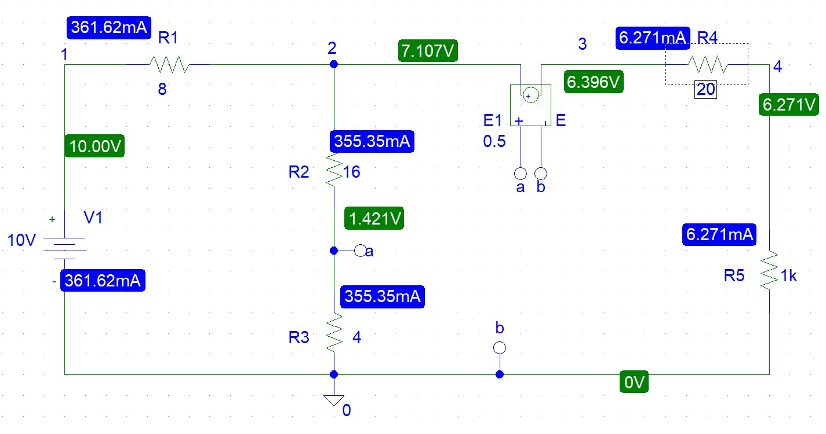

***Figure - 1***

Figure of circuit with VCCS (Voltage-controlled current source):

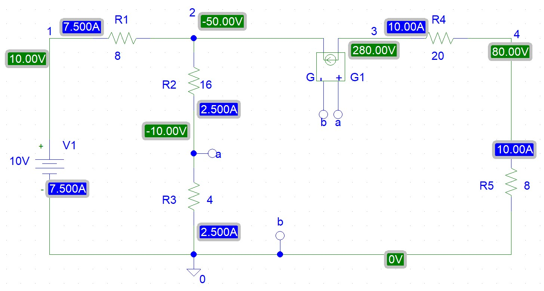

***Figure - 2***

Figure of circuit with CCVS (Current-controlled voltage source):

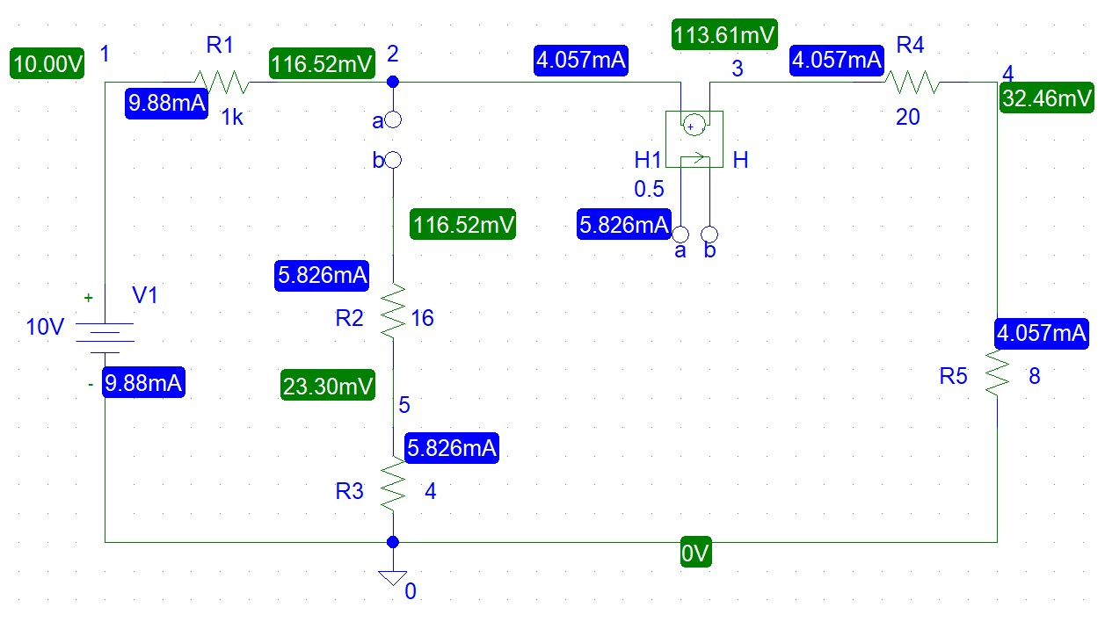

***Figure – 3***

Figure of circuit with CCCS (Current-controlled current source):

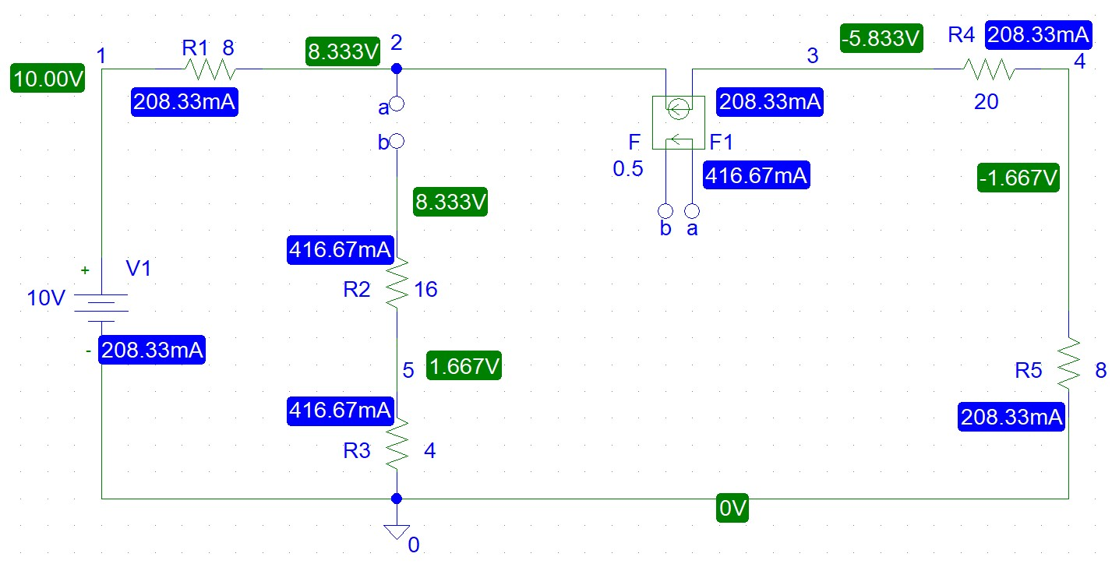

***Figure - 4***

Figure of circuit with VCCS and CCVS:

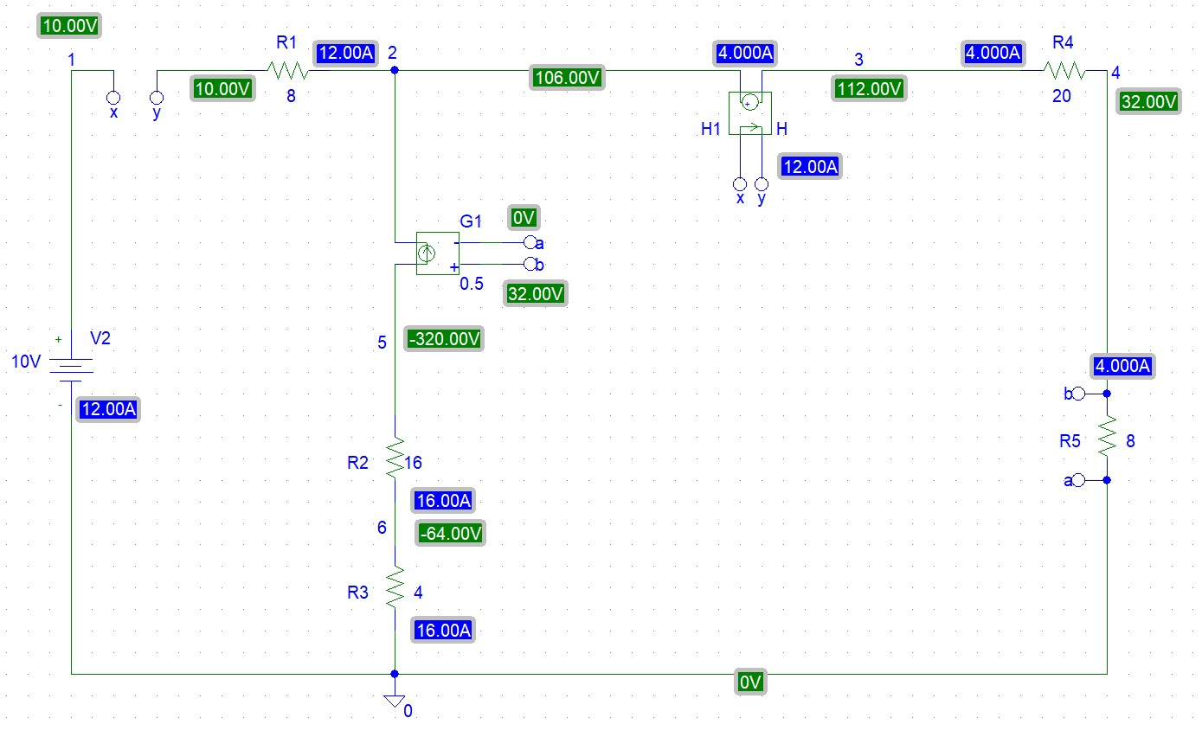

***Figure - 5***

**Post-Lab Questions**

1. Theoretically calculate all the currents and the voltages for the circuit shown in *Figure 5*.

Solution:

Let, $I_{s}=I_{1}$, $V_{ab}=8I_{2}$

Applying KCL at node 2,

$$I_{1}+0.5V_{ab}=I_{2}$$

Or, $0.5×8I_{2}=I_{2}-I_{1}$

$∴3I_{2}+I_{1}=0$………(i)

Applying KVL at super mesh,

$$10-8I_{1}-0.5I_{1}-28I_{2}=0$$

$∴8.5I_{1}+28I_{2}=10$………(ii)

Solving equations (i) and (ii), we get,

$$I_{1}=I_{s}=-12A$$

$$I_{2}=4A$$

So, $V_{ab}=8I_{2}=8×4V=32V$

Current passing through $VCCS=0.5V_{ab}=0.5×32A=16A$

Let at node 2, Voltage = V2

Applying KCL and Ohm’s law at node 2,

$$\frac{V_{2}-10}{8}+\frac{V_{2}-0.5I_{s}}{28}=16$$

$$∴V_{2}=106V$$

At node 3,

$$V_{3}=4×28V=112V$$

At node 5,

$$V_{5}=\left(-16\right)×20V=-320V$$

At node 6,

2. Compare the theoretical solution of the circuit shown in *Figure 5* with the solutions obtained from PSpice simulation.

Solution:

|  |  |
| --- | --- |
| Theoretical Value | PSpice Simulated Value |
| Is = -12A | Is = -12A |
| I2 = 4A | I2 = 4A |
| Current passing through VCCS = 16A | Current passing through VCCS = 16A |
| V1 = 10V | V1 = 10V |
| V2 = 106V | V2 = 106V |
| V3 = 112V | V3 = 112V |
| Vab = 32V | Vab = 32V |
| V5 = -320V | V5 = -320V |
| V6 = -64V | V6 = -64V |

From the table, it is evident that the theoretical values and the PSpice simulated values for the circuit are identical.

**Current Values:**

* The theoretical value of $I_{s}=-12A$ matches the PSpice simulated value.
* The current $I_{2}=4A$ is also consistent in both cases.
* The current passing through the VCCS (Voltage Controlled Current Source) is 16A in both the theoretical and simulated results.

**Voltage Values:**

* All voltage values, including V1, V2, V3, Vab, V5, and V6, are exactly the same in both theoretical and simulated calculations.
* For instance, $V_{1}=10V, V_{2}=106V$ and $V_{ab}=32V$ are identical in both columns.

Since there are no discrepancies between the theoretical and simulated values, we can conclude that the theoretical analysis accurately predicts the circuit’s behavior as verified by the PSpice simulation. This validates the correctness of the theoretical approach and confirms the accuracy of the circuit modeling in PSpice.

**DISCUSSION:**

The superposition theorem is a fundamental principle in electrical circuit analysis that allows the determination of circuit responses when multiple independent sources are present. In this experiment, we analyzed a circuit containing different types of dependent sources, including voltage-controlled voltage sources (VCVS), voltage-controlled current sources (VCCS), current-controlled voltage sources (CCVS), and current-controlled current sources (CCCS).

By applying Kirchhoff’s Current Law (KCL) and Kirchhoff’s Voltage Law (KVL) at different nodes, we derived the theoretical values for the voltages and currents in the circuit. The circuit was also simulated using PSpice to compare the results. Theoretical calculations and PSpice simulations produced identical values, verifying the accuracy of our calculations and the superposition theorem.

Through this analysis, we confirmed that the total response in a linear circuit with multiple sources can be obtained by summing the individual responses from each independent source. Any small discrepancies observed were due to practical limitations such as component tolerances and minor voltage fluctuations.

**CONCLUSION:**

The experiment successfully verified the superposition theorem by comparing theoretical and simulated values. The results demonstrated that the theorem holds true in circuits with dependent and independent sources. Theoretical calculations were in complete agreement with the PSpice simulations, proving the accuracy of the method used. This experiment reinforced our understanding of linear circuit analysis and highlighted the importance of simulation tools in validating theoretical principles. Further practical implementation with real components could provide additional insights into the minor deviations that may occur in experimental conditions.